Genome Island: A User's Guide
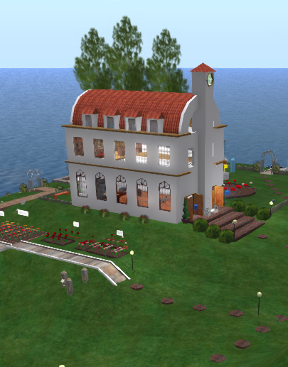 | - Your Passport to Genome Island
 | - The Abbey
- The Greenhouse
- The Abbey Gardens
 | - The Cattery
 | - The Terraces
 | - Genomes and Bioinformatics
 | - The Tower
 | - The Gene Pool and Atelier
 | - Sample Assignments
The Abbey of St Thomas is a simple white building riding the crest of a gentle hill. Two banks of windows look out onto a greenhouse and gardens in which Mendelian inheritance patterns are demonstrated. Inside the Abbey is a painting of Mendel in his abbot’s robes, an old photo of Mendel with his fellow monks, and lying on a downstairs table, a fading copy of Mendel’s famous paper on plant hybrids. A fire takes the chill out of the winter air. In the reading room upstairs, a chessboard is set out, waiting for somebody to make the next move.
In the virtual world of Second Life, the Abbey shares Genome Island with other buildings, gardens and pools that house representations of the work of other geneticists: the structure of DNA, genetic coding, genome organization, a human chromosome gallery, genetic regulation, bioinformatics and population genetics. Science progresses by the creation of virtual worlds that overlie everyday and not-so-everyday phenomena. The metaverse of Second Life provides a vision of that world that anyone can enter and experience. If you are an instructor thinking about bringing a class to Genome Island, this guide is for you. If you are a student or even just a casual visitor to Genome Island, feel free to peek!

There is no fixed pathway for moving through the various activities to be found on Genome Island. In the sections that follow, each activity is treated as an independent entity. You may want to start with Mendelian genetics in the Abbey or with DNA in the Tower. The Human Chromosome Gallery in Tower can provide a useful transition point between molecular genetics and inheritance patterns. Much of the information you find in this Guide will also be found in notecards associated with the signs that describe each activity. In general, reading the informational notecards will give students the background needed for making sense of the activity.
Genome Island is not intended to be instructor-free. This is a place where instructors and students can can meet and talk about genetics. Since most activities can be used for multiple purposes, instructors can define the context in which each activity should a approached. There are meeting areas in several locations around the island: the expanding conference table in the Abbey, small (but also expanding) tables in two gazebos, beanbag chairs on the Cell and Tower Terraces and the Genome Science Theatre for larger groups. Most of these are placed so that text or voice conversations in different areas will not interfere with one another.

